
Nijmegen School of Management
Department of Economics and Business Economics
Bachelor’s Thesis in Economics (MAN-BIM304A)

How does the relationship between AI adoption and economic growth vary across levels of economic development?

By Mátyás Varga-Etele (S1121420)
Nijmegen, 31 May 2026


Program: Economics and Business Economics
Specialisation: Financial Economics
Supervisor: Lamar Crombach
Table of Contents
Abstract 2
1 Introduction 3
2 Literature Review 5
2.1 Defining Artificial Intelligence 5
2.2 AI and Economic growth 5
2.3 AI adoption and Inequality 6
2.4 Endogenous Growth theory 7
2.5 AI as a General-purpose technology 8
2.6 Technological Diffusion and Institutional quality 8
2.7 Summary and Hypothesis 9
3 Methodology 10
3.1 Research Design 10
3.2 Variables and Data sources 11
3.3 Regression Equation 13
3.4 Descriptive Statistics and Correlation Matrix 14
3.5 Limitations of the Methodology 16
4 Results 18
4.1 Baseline Model 18
4.2 Extended Model 19
4.3 Marginal effects of AI adoption 21
4.4 Robustness Checks 22
4.5 Limitations 24
5 Conclusions 26
Appendix 29
Additional Summary of the Results 29
Additional Coefficient Tables for Robustness Checks 30
References 33
Planning 37

Abstract
This paper’s main focus is on the relationship between AI adoption and economic growth and how this relationship changes across different economic developmental levels. The motivation behind this research is to address the growing concern that AI adoption might result in increased global inequality, because developed countries may benefit more from it than less developed nations. Furthermore, the theoretical framework of this text incorporates endogenous growth theory, diffusion of innovations theory, the view that AI might be a general-purpose technology and much more to create its initial hypothesis. This hypothesis states that the effects of AI adoption on economic growth should be conditional on economic development and that more advanced economies should have a more positive effect than less advanced economies.
Moreover, the paper uses panel data from 2004 until 2024 to test this hypothesis. The regression model uses fixed effects, several control variables and standard errors are clustered at the country level. AI adoption is proxied by Google Trends data for the search term “artificial intelligence”, while economic development was measured by the Human Development Index (HDI). The analysis includes several robustness checks as well.
The findings provide partial support for the hypothesis. AI-related interest does not appear to have a significant relationship with economic growth alone. Furthermore, the interaction term between AI Trends and HDI became positive, suggesting that the effects of AI Trends become more positive as countries become more developed. In conclusion, the findings suggest that AI-driven economic growth may be distributed unequally between more and less developed economies and it is possible that only countries with the adequate structural and institutional environments can benefit substantially from this AI-driven technological change.

Introduction
Artificial Intelligence (AI) is predicted to transform labour markets and entire economic sectors around the world (Cazzanige et al., 2024). Bold predictions such as these are based on credible research done by major institutions, such as the International Monetary Fund (IMF) and credited academics. Moreover, the number of people using generative AI tools, such as ChatGPT has been growing and it already reached 3 billion visits per month in 2024 (Wang & He, 2024) and according to ChatGPT’s own latest estimate, this number reached 5.8 billion monthly visits in September of 2025 with approximately 800 million weekly active users (Singh, 2025).
This technology has the potential to lead to productivity growth in many industries, further resulting in higher economic growth (Damioli et al., 2024). Empirical data supports the claim that AI technologies has been significantly correlated with firm-level productivity in the period between 2002 and 2018 in Taiwan (Yang, 2022). Another example of productivity growth by AI can be seen in the financial industry. AI tools can fundamentally change the financial industry with massive advances in firm-level productivity (Golic, 2019). In other words, a significant amount of literature has been published on AI’s effects on productivity-levels in an economy. According to economic theory, these productivity gains should result in increased economic growth in the sectors affected by this technology (Babina et al., 2024).
Evidence for the potential of AI-driven economic growth can be found in many economic papers. However, the distribution of the benefits of this growth is not a main area of concern in much of the literature. Furthermore, the distributional effects of any disruptive technology such as this on economic growth is expected to be unequal, as it was before with other technologies in history (Batabyal et al., 2025). Close to 40 percent of all global employment could be exposed to AI in the future (Cazzanige et al., 2024). Out of this employment loss it is not clear which regions in the world can lose the most jobs and which regions will gain the most benefits of the transformation.
There are different challenges that countries face due to their differences in how their economies have developed. While economically advanced nations are more exposed to initial economic shocks caused by artificial intelligence, they are the ones that are expected to receive the most out of the benefits of this added economic growth produced by it as well (Cazzanige et al, 2024). Poorer economies might not be as vulnerable in the short-term, but the long-term effects are very much uncertain (Cazzanige et al., 2024).
Despite the enormous potential of AI-driven economic growth, recent economic research suggests that the benefits will not be distributed evenly between economies, workers and sectors overall, this could result in the widening of global wealth inequality across nations (Minniti, 2025). Dynamic general equilibrium analysis reveals that AI-driven economic growth could almost entirely be enjoyed by the most economically advanced nations, especially in the short-term (Liu, 2025). These findings are alarming from social, economic and ethical perspectives. In addition, understanding what inequality risks AI could bring in the future is crucial for predicting the true extent of the effects of AI adoption on the global economy.
Therefore, the main aim of this article is to do research about what the distribution of AI-driven economic growth around the globe will likely to be with a specific focus on economic development as a measure to differentiate between economic regions. Especially thinking about the already deep regional and economic inequalities around the globe, it is important to ask what happens to countries who are not as developed as the economically advanced nations, who are leading this technological transition.
Since the research on AI is still relatively scarce due to the situation and the facts around it are constantly changing, this article is meant to contribute to the existing literature with a special focus on the differences in economic outcomes based on a country’s development. Key points that differentiate this research and therefore that extend the existing body of literature are a cross-country perspective, a focus on linking AI’s economic effects to economic development and a perspective that analyses AI’s distributional effects between countries.
The paper’s objective is to create a regression based on publicly available data, for example on AI adoption, GDP growth and the Human Development index. This regression measures AI-driven economic growth with economic development as one of the broad independent variables. The structure of the paper is as follows, section 2 contains the literature review, section 3 is the methodology, section 4 will contain the results of the regression model and finally section 5 contains the conclusions about the results and an overall review of the article’s findings.

Literature Review

Defining Artificial Intelligence
There are several definitions of Artificial intelligence (AI) present in the literature, one of these is the definition invented by Alan Turing, where artificial intelligence was described as “the science and engineering of making intelligent machines” (Turing, 1950). Furthermore, this article will use the most common definition for AI derived by Russel and Norvig, where AI is defined as something that “enables the machine to exhibit human intelligence, including the ability to perceive, reason, learn, and interact with beings” (Collins et al., 2021). Moreover, since this paper examines the effects of the most commonly used and adopted artificial intelligence systems, the term AI will be used to refer to systems, such as large language models (LLMs), for example ChatGPT and BERT as well as other AI systems that are the most popular computer systems in the market at the specific period of analysis (Bender & Koller, 2020). Technological advances in machine learning and natural language processing (NLP) have made AI more integrated into economic processes, which raises important questions about the economic consequences of this change (Bender & Koller, 2020).

AI and Economic growth
Although many major institutions focus on this topic, such as the IMF, research around the effects of AI on economic growth is still very limited, since the wide-scale adoption of AI into economic processes around the world is a relatively recent phenomenon. However, there are various studies researching the subject nevertheless, for example some articles focus on the possibility that the introduction of AI can lead to a technological paradigm shift, which can be comparable to inventions such as the internet (Damioli et al., 2024). Much of the current discussion about AI revolves around precisely this theory, that these systems will lead to productivity growth in many sectors of the economy, such as finance or even in agriculture, which will potentially result in increased economic growth (Bjola, 2022; Golic, 2019). This theory fits into the idea of innovative diffusion, where technologies get adopted that exhibit relative advantage gains, compatibility with existing economic processes and observability of results (Rogers, 1983). All of these factors influence rate of adoption, but the speed of this AI adoption remains uncertain, considering the nature of technological progress in general and it is influenced by certain economic indicators such as general infrastructure or institutional capacity (Bjola, 2022).
One particular sector for example that AI could transform is the financial sector. Due to the financial industry’s tendency to be digitally advanced in analytics processing, the sector is one of the earliest adopters of AI technologies, the expected benefits are projected to be enormous, for example the ability to provide better and faster services to clients at lower costs, so essentially productivity gains caused by AI (Golic, 2019). Firms that adopt AI tools are more likely to develop new products and have higher productivity growth than firms that did not adopt these technologies (Babina et al., 2024). Moreover, firm-level analysis further provides evidence for AI driven economic growth (Yang, 2022).

AI adoption and Inequality
Despite these promising findings, most researchers agree that the distribution of the economic benefits of AI is highly unequal across countries with different economic development levels. AI usage is mostly concentrated in highly educated demographic groups, which favours developed countries (Yan & He, 2024). Cross-country analysis reveals that wealthier and more urbanized regions exhibit higher levels of AI adoption (Goel & Nelson, 2025). Middle- and high-income countries account for the vast majority of the global usage of this technology (Khan et al., 2024). These findings suggest that there could be structural limits for low-income countries in their ability to economically gain from the AI transformation.
Furthermore, this uneven adoption of AI technologies raises important issues around the potential for increased global inequality that could arise from this AI transformation. Countries with higher levels of human capital are projected to benefit more from using AI tools (Batabyal et al., 2025). Similarly, there is a symbiotic relationship between human capital and AI, which means that productivity growth by AI is largely dependent on the worker’s ability to use AI tools (Gomes, 2025). Moreover, labour markets could radically transform according to this logic, reducing demand for so called middle-productivity jobs (Cazzaniga et al., 2024). This transformation could create more economic inequality within and between countries. Several studies reach similar conclusions about the potential for increased wealth inequality. AI has the potential for productivity growth in different sectors, but it could also replace certain processes entirely (Fleire, 2025). In addition, wealth distribution inside and between countries could change, because AI could alter capital accumulation dynamics inside firms and sectors (Liu & Liang, 2025). To summarize, AI-driven economic growth is very likely dependent on the general economic development of a given region.

Endogenous Growth theory
There are many economic theories about how technological innovation can lead to sustained long-term economic growth. General neoclassical economic theory treats technological progress as an exogeneous factor that develops outside the economic system. This can be called exogeneous growth theory. In contrast, Romer’s (1990) endogenous growth theory focuses on the idea that technological advancements are key drivers themselves of long-run economic growth, in other words he treats technology as an endogenous variable when it comes to modelling long-term economic outcomes. In his theory, technological innovations, such as AI tools function as non-rival economic goods, which means that many agents in an economy can use them as a resource without actually losing their initial value, in other words without depleting their fundamental value. Furthermore, in this framework innovation and knowledge accumulation can function as key drivers of sustained long-term GDP-growth.
In addition, artificial intelligence as a technological tool can be seen as a non-rival good according to this theory. Specifically, AI has the capacity to increase economic productivity by increasing the efficiency of information processing and knowledge production. AI systems can automate many cognitive tasks and in turn they can accelerate economic innovation. Many papers focus on this topic by connecting endogenous growth theory to AI as a non-rival technological good. Aghion et al. (2019) argues that AI has the ability to automate certain production and innovation processes acting as a major driver of economic growth. Moreover, Cockburn et al. (2018) states similar conclusions, it hypothesises that AI could revolutionize technological progress itself and in turn could speed up technological innovation in the future. Romer’s (1990) perspective on long-term economic growth and the role of scientific progress is relevant to the research question of the paper, since it implies that a country’s ability to benefit from new innovations can depend on endogenous factors, such as education levels, institutional quality and infrastructure. This essentially means that economic outcomes could differ largely between different levels of economic development across markets.

AI as a General-purpose technology
Economists classify different kinds of tools, innovations and resources in the economy based on their functions and potential use cases. One of these classifications is general-purpose technologies, which are defined as technologies that can be used in many different sectors of the economy and therefore, they can fundamentally change production systems as a whole. Specific innovations that are examples for this idea are electricity, the steam engine and the internet. Moreover, some recent scientific articles link AI to this concept and they argue that it could be a kind of general-purpose technology. They state that AI has the potential to completely disrupt production systems in the future as the reason for this classification (Brynjolfsson et al., 2021).
General-purpose technologies can only generate productivity growth, once the required investments in the economy are made, for example in the case of electricity, places that use electricity today have built the adequate infrastructure to be able to use this resource. In the case of AI, something similar could happen, where only the regions that have developed the required institutional frameworks and infrastructures could benefit from AI and the regions that are unable to do this could stagnate. Therefore, the level of AI adoption can be influenced by how developed a country is and this will have an effect on economic growth prospects. In other words, this theory further substantiates the claim harnessing the potential benefits of AI could be conditional on economic development (Brynjolfsson et al., 2021).

Technological Diffusion and Institutional quality
Rogers’ (1983) diffusion of innovations theory further supports these findings. It states that technologies get adopted faster as they exhibit clear productivity gains and compatibility with already existing infrastructures and networks. This process depends heavily on economic, social and institutional conditions in a particular country or region. In AI’s case, adoption clearly depends on the level of digital infrastructure. Therefore, countries with low digital literacy, weak digital infrastructure and general low levels of human capital may find it difficult to adopt AI technologies at even a comparable rate as countries that do not face these problems do.
Furthermore, an important issue that is relevant for the adoption of AI is institutional quality and responses from policy makers. Countries that have strong institutions, functioning legal and political systems can enact strong protections and regulations when it comes to AI technologies. On the other hand, countries with weak institutions will not be able to create similar innovation-friendly conditions that could result in increased AI-driven economic growth. Consequently, the role of institutions and policy can also influence the economic outcomes of adopting AI technologies in an economy.

Summary and Hypothesis
To summarize, theories around economic growth and technological innovations, such as endogenous growth theory, technological diffusion theory and the theory about general-purpose technologies all suggest that AI adoption rates are linked to economic development and the economic effects of this technological adoption could be different across countries with differing levels of economic development.
This article will examine this relationship between AI and economic growth, especially focusing on the role of economic development and who and which regions can benefit more from this technological advancement. Based on the review of the available literature on this subject, the paper’s theoretical framework and initial hypothesis for its analysis is that the effect of adopting AI systems into employment-related processes on economic growth is dependent on a region’s economic development. In other words, the hypothesis is that there is a positive relationship between AI driven economic growth and the level of economic development.

Methodology

Research Design
This research paper is a quantitative study. The hypothesis of this paper predicts that there is a positive relationship between AI trends and economic growth, and this relationship becomes more positive as the level of economic development increases. The period when all data was collected is between 2004 and 2025. However, the final regression model relies on observations until 2024, because data availability is limited for many variables in 2025. Moreover, the reason for starting with the year 2004 is that google trends started collecting data in that year and therefore this is the earliest date that the dataset could still have data for. While early AI systems have been used before this date, the period after 2000 and then after 2010 is considered to be the timeframe that the current AI transformation as we know it has started in and is still evolving in (Collins et al., 2021). In addition, the analysis uses data from as many nations as possible, depending on data availability.
Furthermore, the paper uses panel data that contains both cross-sectional and time-series data, this allows for comparing the different outcomes between countries and throughout different years. This is very important, because the economic effects of AI adoption should show major variation between countries based on time and economic development. The regression uses fixed effects. Country fixed effects control for characteristics that are country-specific and remain constant over-time, such as cultural or geographical factors. Moreover, time fixed effects are applied to control for specific events that impact a large part of the cross-section, such as a global recession. Using a quantitative regression model is justified for this paper, because it incorporates specific macroeconomic statistics, such as investment, foreign direct investment, inflation, trade openness, human development index and GDP growth. Using panel data models when modelling economic growth is considered a regular practice in the literature (Fernández-Val & Weidner, 2018). All regressions use Ordinary Least Squares (OLS) for estimating the coefficients and other results. Standard errors are clustered at the country level, this accounts for potential heteroskedasticity and serial correlation issues within countries. Clustering standard errors within countries is justified, because observations from the same country are likely to be correlated with each other, for example GDP growth in one year likely has an effect on the next year’s GDP growth. Therefore, using clustered-standard errors provides more reliable results than using conventional standard errors.

Variables and Data sources
The table below depicts all variables that are used in this regression and their respective sources (Table 1). All datasets are referenced, but there was one small adjustment that was made in the data, so there could be more valid observations. The Human Development Index variable only has data until 2023 for many countries. To maintain consistency in the panel dataset, HDI estimates from 2023 were carried over to the subsequent year of 2024. This method is justified by the fact the Human Development Index combines indicators such as life expectancy, education statistics and real income levels. All of these values change very slowly and therefore HDI measures do not fluctuate much year to year. Nevertheless, this change still introduces a small measurement error and therefore it should be considered a limitation of the analysis.
The dependent variable in the regression is real GDP per capita growth from the World Bank, which is one of the most common economic indicators for this kind of analysis. It captures economic performance better than total GDP growth would, because it takes in account population size and can better measure changes in productivity and living standards within a country overtime. Consequently, real GDP per capita growth functions as a suitable indicator for the economic performance of countries.
The main independent variable in this analysis is the AI google trends data, which is based on Google Trends search data for the term “artificial intelligence”. Google Trends do not report absolute numbers of searches, instead it uses normalized values between 0 and 100, where 100 represents the highest search activity for the given period of analysis, it reports 0 for years with very low search activity (compared to other years for the same country). The google search scores are from the Google trends website, and the data was collected by looking at individual countries for individual years and collecting scores for every full year (2004-2025), this was done via Python, cause manually it would have been inconvenient and it could have introduced added human errors to the regression (Google Trends, 2026). Google Trends was selected, because it is one of the only publicly available sources that allows for cross-country panel data on AI- interest and awareness. After collection, the variable was standardized for the regression with using the z-score method. This standardization transforms the AI Google Trends variable to have a mean of zero (throughout all the data so including 2025 estimates) and a standard deviation of one, this makes it possible to compare different countries, and it is more fitting to measuring changes that happen overtime. The analysis uses this variable as proxy to measure the economic and social interest for AI technologies over time. Its value represents how aware and ready a population is for adopting AI technologies in economic processes. While this variable is not directly measuring firms adopting AI technologies, I capture a country’s public awareness and exposure to AI-related technologies. In addition, the underlying assumption is that more AI search activity means that the country will be more likely to adopt AI technologies.
Another key independent variable is the human development index (HDI), which captures the economic development of countries. HDI combines several indicators related to education, income and life expectancy, which overall provides a measure for a country’s level of socio-economic development. In addition, the “artificial intelligence” Google search scores and the HDI variable will form an interaction variable, which is the central explanatory variable in the regression model. This interaction term is designed to test whether the paper’s hypothesis holds, which predicts that the relationship between AI adoption and economic growth varies massively across levels of economic development.
Several control variables are introduced to the final regression specification. Firstly, the investment control variable is specifically measured by the gross annual capital formation as a percentage of GDP. The reason behind including this variable is that capital accumulation is a key indicator for economic growth. Moreover, foreign direct investment (FDI), which was measured by net inflows as a percentage of GDP, is used to control for international capital flows and foreign investment activities. Trade openness, measured as total trade with other countries as a percentage of GDP, is included to analyse the effects of how integrated into global markets a domestic economy is. Trade openness might also influence GDP growth through accessing other markets and technology transfers. Lastly, inflation was added as an indicator of macroeconomic stability in a country. It was measured using annual consumer price inflation. Inflation can have a negative effect on investments and long-term economic performance. All of these control variables are from the World Bank’s databank.
To summarize, together with country and time fixed effects, added control variables and clustered standard errors on the country level, were introduced to improve the reliability of the regression’s results on the relationship between AI adoption, economic development and GDP per capita growth.

Table 1. Variables Table
Variables | Full Name | Source
$$GDPpcGrowth_{\left\{i,t\right\}}$$ | GDP per Capita Growth | GDP per Capita Growth data by the World Bank
$$AITrendsStd_{\left\{i,t\right\}}$$ | Standardized AI search interest (Goggle Trends data) | Google trends data about the term “artificial intelligence”, standardized with z-score method
$$HDI_{\left\{i,t\right\}}$$ | Human Development Index | HDI by UNDP
$$Investment_{\left\{i,t\right\}}$$ | Investment Control Variable  (basic macroeconomic indicator) | World Bank Group  Gross Capital formation  (% of GDP)
$$FDI_{\left\{i,t\right\}}$$ | Foreign Direct Investment Control Variable  (basic macroeconomic indicator) | World Bank Group  Foreign Direct Investment, net inflows (% of GDP)
$$TradeOpenness_{\left\{i,t\right\}}$$ | Trade Openness Control Variable  (basic macroeconomic indicator) | World Bank Group  Trade (% of GDP)
$$Inflation_{\left\{i,t\right\}}$$ | Inflation Control Variable  (basic macroeconomic indicator) | World Bank Group  Inflation, consumer prices (annual %)
$$μ_{i}$$ | Country Fixed Effects | Included in the model.
$$λ_{t}$$ | Time Fixed Effects | Included in the model.
$$ε_{\left\{i,t\right\}}$$ | Error term | No source needed
Notes: i = specific country, t = specific year

Regression Equation
The regression equation used in this analysis is presented in this section (1 Regression Equation). The equation is based on the theoretical framework that was developed in the literature review. It particularly uses endogenous growth theory, because it hypothesizes that the economic effects of AI adoption change depending on a country’s level of economic development. The interaction term between AI trends and HDI is the central focus of the paper, because it tests how the effects of AI adoption on economic growth varies across economic development levels. A positive coefficient for the interaction term between AI trends and HDI variables would indicate that the relationship between AI interest and economic growth is more positive at higher levels of economic development. This finding would provide support for the thesis’s hypothesis.

(1) Regression Equation Specification

$GDPpcGrowth_{\left\{i,t\right\}}$ $=$
$β_{0}+ β_{1}AITrendsStd_{\left\{i,t\right\}}$ $+ β_{2}HDI_{\left\{i,t\right\}}$ $+ β_{3}\left.\left(AITrendsStd_{\left\{i,t\right\}}×HDI_{\left\{i,t\right\}}\right.\right)$ $+ β_{4}Investment_{\left\{i,t\right\}}$ $+ β_{5}FDI_{\left\{i,t\right\}}+ β_{6}TradeOpe{nness}_{\left\{i,t\right\}}$ $+ β_{7}Inflation_{\left\{i,t\right\}}$
$+ μ_{i}$ $+ λ_{t}+ ε_{\left\{i,t\right\}}$

Notes: Dependent Variable = GDP per Capita growth
$β₁$ = Measures the effect of AI trends variable on the dependent variable
$β₂$ = Measures the effect of HDI index on the dependent variable
$β₃$ = Measures the effect of the interactive variable between HDI and AI trends on dependent variable.
$β₃$ = Measures the effect of investment, proxied by gross capital formation as a percentage of GDP.
$β₃$ = Measures the effect of foreign direct investment as a percentage of GDP.
$β₃$ = Measures the effect of trade openness on economic growth.
$β₃$ = Measures the effect of inflation on economic growth.
$μ_{i}$ = Represents country fixed effects.
$λ_{t}$ = represents year fixed effects.
$ε_{\left\{i,t\right\}}$= represents the error term.
All coding related sources are included in the references, specific coding can be accessed via the GitHub link at the very end of the paper.

Descriptive Statistics and Correlation Matrix
For all the variables used in this regression, there is a descriptive statistics table and a correlation matrix included for the dependent and independent variables. The software used to process data and create the regression is python. Table 2 presents the descriptive statistics for both dependent and independent variables and Figure 1 presents the correlation matrix heatmap.
The descriptive statistics table illustrates that there is considerable variation between different countries and years. Real GDP per capita has a mean of 2.16 percent and a standard deviation of 4.8 percentage points, this suggests that there are massive differences between countries. The AI trends variable has a mean close to zero, because it was standardised using the z-score method. The HDI variable has a mean value of 0.733, this indicates that the sample successfully includes many countries with substantially different economic developmental levels. Moreover, the control variables also exhibit relatively large variations. However, large variations in the dataset were expected given the large number of countries and years that the analysis uses. Nevertheless, the paper includes several robustness checks in the results section, one of which excludes the extreme outlier values from the dependent variable.
Figure 1 illustrates the correlation matrix with a heatmap. Overall, pairwise correlations appear to remain at a relatively low level, this suggests that it is unlikely that there are severe multicollinearity issues in the regression. The highest correlation was between HDI and trade openness (0.35), indicating that more developed countries tend to have more open economies. All other variables demonstrate very low levels of pairwise correlations.

Table 2. Descriptive Statistics Table
 | observations | mean | std | min | 25% | 50% | 75% | max
gdp_pc_growth | 2611 | 2,1636 | 4,8030 | -36,8245 | 0,3627 | 2,1940 | 4,2894 | 91,7814
ai_trends_std | 2611 | -0,0968 | 0,8640 | -1,8209 | -0,6187 | -0,3216 | 0,1368 | 4,5826
hdi | 2611 | 0,7327 | 0,1587 | 0,2790 | 0,6090 | 0,7620 | 0,8660 | 0,9720
investment | 2611 | 23,0807 | 6,7882 | 1,2252 | 18,9224 | 22,3851 | 26,0033 | 70,1086
fdi | 2611 | 6,0539 | 28,7192 | -391,5551 | 1,3145 | 2,7977 | 5,2504 | 452,2210
trade_openness | 2611 | 88,0286 | 53,2613 | 2,6988 | 54,1916 | 75,9388 | 107,5985 | 437,3267
inflation | 2611 | 5,9587 | 17,7172 | -16,8597 | 1,6140 | 3,3619 | 6,6060 | 557,2018

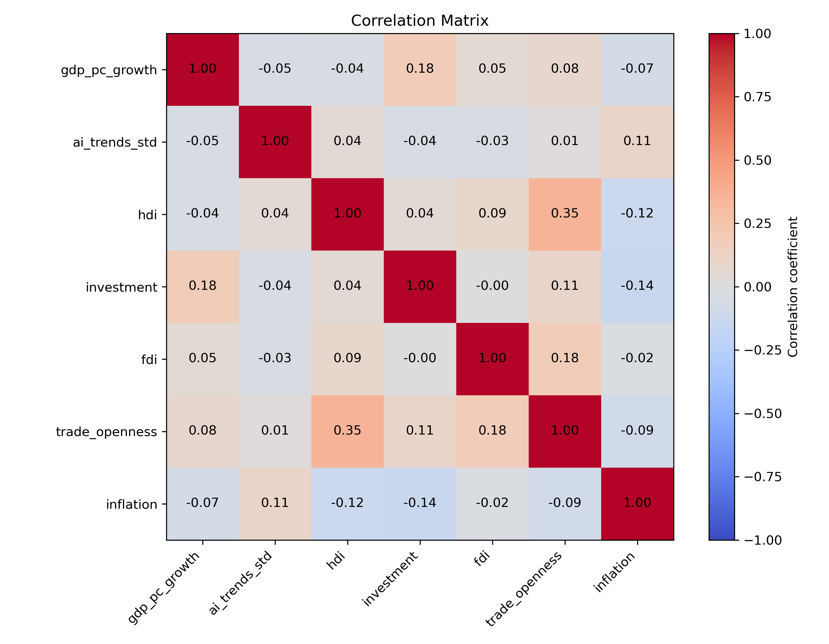
Figure 1. Correlation Matrix Heatmap

Limitations of the Methodology
An earlier model used AI preparedness scores that were calculated by the IMF. However, there were severe multicollinearity problems with the regression between the AI Preparedness Index (AIPI) and the Human Development Index (HDI) variables, these variables both capture some indicators of general economic development and therefore show a significant level of correlation between their values. Because of this reason, the actual equation ended up not using these scores. This made the correlation much more effective and Google trends alone can still function as a key indicator of AI adoption rates and implementation of AI technologies. HDI was kept and AIPI was dropped from the regression, because HDI is still one of the most widely used indicators for economic development and therefore this variable is important for answering the central research question.
Furthermore, an important limitation is the problem with heteroskedasticity. The dataset includes very different countries with different growth volatility and economic structures, this makes it unlikely that the variance of the error term can remain constant across observations. To partially address this issue, the regression uses standard errors that are clustered on the country level.
An additional potential problem could be endogeneity. This is because higher economic growth itself might increase AI adoption as well, since wealthier economies have higher capacity for investment. Therefore, it is possible that there is reverse causality between AI adoption and economic growth. This issue is partially addressed by adding several control variables, and country and time fixed effects to the regression.

Results
This section presents the key empirical findings of this paper. The analysis includes results from two main regression models. The baseline model includes AI trends, HDI, all control variables and fixed effects. The reason for presenting this initial specification is to establish the relationship between AI-related interest and economic growth, while controlling for other factors that influence economic growth, such as investment, foreign direct investment, trade openness and inflation.
Furthermore, the extended model includes the main variable of interest, which is the interaction term between the AI trends and HDI variables, while keeping all other variables in the specification. The purpose for this extended model is to test the main hypothesis of the paper and establish how AI adoption and economic growth differs across levels of economic development. After explaining the results of the two regression specifications and presenting the main findings, this section includes an assessment of various robustness checks and limitations.

Baseline Model
Column (1) of table 3 reports on the results of the baseline model. This specification contains AI Trends, HDI, all control variables and both country and time fixed effects. The coefficient for AI trends (-0.177) is negative, but not statistically significant. This result suggests that AI-related search interest alone does not have a clear relationship with GDP per capita growth, once other control variables are included into the regression.
In addition, the coefficient for HDI is positive, but similarly to AI trends, it does not show any significance. Although, general economic theory predicts that there is a positive relationship between economic development and economic growth, the addition of country fixed effects means that the regression captures with-in country changes over-time. Since HDI levels change very slowly, it is difficult to predict what independent effect it has in this specification.
The coefficients for control variables are more informative. Investment has a positive and highly significant coefficient (0.142), this indicates that higher levels of capital formation are associated with stronger economic growth. Trade openness also has a positive and statistically significant relationship with real GDP per capita growth, this suggests that countries, which are more integrated into global markets experience higher levels of GDP growth as well. As a counter example, inflation has a negative coefficient (-0.018), which is also highly significant, this finding is supported by general macroeconomic theory, which states that macroeconomic instability can negatively influence economic growth rates. Lastly, foreign direct investment (FDI) has a positive insignificant coefficient. A possible reason behind this could be that the economic effects of FDI flows often come in the long-term, after an initial delay period. Also, it could be that other variables partially capture some of the effects of this variable, for example investment.
To summarize, the baseline model suggests that traditional macroeconomic factors, such as investment, trade openness and inflation remain the key determinants of economic growth. However, AI-related interest alone does not appear to be an important factor in this initial model. This finding is the partial motivation behind the inclusion of the interaction term between AI adoption and GDP per capita growth and to find out how it differs across different levels of economic development.

Extended Model
Column (2) of table 3 reports the results of the extended model. This second specification includes the interaction term, which is the main variable of interest for this paper. The coefficient for AI Trends stayed negative (-0.829), but it is still not significant. However, this coefficient cannot be interpreted in isolation since the total effect of AI adoption depends on the interaction term as well. In other words, the effects of AI-related interest should vary across levels of economic development.
The interaction term between AI Trends and HDI is positive (0.968), but not statistically significant. Although the result remained insignificant, this positive coefficient shows consistency with the hypothesis that was developed in the literature review section. This finding is further written about in the marginal effects analysis subsection below.
In addition, the coefficient on HDI is positive (1.942) and insignificant. This coefficient increased substantially from the baseline model’s result (0.049). This increase can be explained by the fact that HDI only measures the effect of AI trends being equal to zero. Since the interaction term allows for variation between different developmental levels, some parts of what the initial baseline coefficients captured are now captured in the interaction variable. As a consequence, the coefficient increased substantially.
The control variables remain mostly unchanged compared to the initial model. The investment coefficient stayed positive and highly significant. FDI results stayed exactly the same as before, staying positive, but insignificant. Trade openness and inflation coefficients remained mostly similar, with both of the findings staying highly significant. Therefore, the baseline interpretations about these coefficients largely hold in this model as well.
The explanatory power of the model has increased by only a small amount, with R-squared rising from 0.381 to 0.382. This increase is small, but the extended model still explains more of the variation of the AI Trends and HDI variables than it was previously able to do. Additionally, the final regression model provides more information about the interaction between AI adoption and economic development. In conclusion, these findings provide partial support for the main hypothesis of this paper that the economic effects of AI adoption become more positive at higher economic developmental levels. However, because the coefficient is not statistically significant, the findings should be interpreted as only suggestive evidence.

Table 3. Regression Table
Variable | (1) Baseline Model | (2) Extended Model
AI trends | -0.177 | -0.829
 | (0.190) | (1.040)
HDI | 0.049 | 1.942
 | (7.678) | (8.767)
AI trends × HDI |  | 0.968
 |  | (1.326)
Investment | 0.142*** | 0.140***
 | (0.025) | (0.025)
FDI | 0.005 | 0.005
 | (0.003) | (0.003)
Trade openness | 0.048*** | 0.046***
 | (0.009) | (0.009)
Inflation | -0.018*** | -0.017***
 | (0.003) | (0.003)
Country FE | Yes | Yes
Year FE | Yes | Yes
Observations | 2611 | 2611
R-squared | 0.381 | 0.382
Notes: Standard errors in parentheses. Country and year fixed effects included. Standard errors clustered at the country level. * p<0.10, ** p<0.05, *** p<0.01.

Marginal effects of AI adoption
Figure (2) illustrates the marginal effect of AI Trends variable on expected GDP-per-capita growth and its variation across economic development measured by HDI. This figure further illustrates the findings of the extended regression specification. The upward sloping line indicates a linear relationship. This essentially suggests that as countries reach higher levels of economic development, the effect of the AI trends variable on GDP growth becomes more positive. In addition, the figure includes 95 percent confidence intervals around the estimated marginal effects of AI adoption.
First of all, at low levels of economic development (with HDI around 0.3-0.5) the marginal effect on economic growth is very negative (-0.26). This implies that AI adoption is associated with short-term growth reductions. This could be explained by adjustment costs, insufficient infrastructure, weaker digital capacity or lower levels of human capital. In these countries, AI technologies could still be a topic of interest, but because of structural limitations, they are unable to translate this into actual productivity gains in specific sectors of their economies.
Furthermore, as HDI increases, the marginal effect on economic growth increases and at very high levels of economic development it becomes positive. When looking at the results for the mean HDI level, the marginal effect is still negative at -0.133. Around the 0.85 HDI level, where AI adoption begins to show a positive effect on expected economic growth. This could be an indication that the hypothesis could partially be correct since this is the effect that we would expect based on it, with the exception that this positive effect is only present for the most developed countries in the dataset. Countries with higher HDI levels have better education systems, better infrastructure and more stable institutions, based on literature and our hypothesis, the expectation is that this will result in higher economic growth attributed to AI technologies for these highly developed economies.
These results are broadly consistent with our hypothesis and the economic theories that were explored in the literature review. Firstly, endogenous growth theory states that technological advancements only cause economic growth, if there are sufficient human capital and infrastructure to support it. In addition, technological diffusion theory is also consistent with these results, which suggests that new technological innovations cannot spread evenly throughout countries around the world, instead they can create massive inequalities due to them having very different effects on countries with different institutions, legal systems, economic conditions and general infrastructure. Therefore, the graph that depicts the marginal effect of AI adoption depending on the level of economic development is largely consistent with the literature and theoretical claims made in this paper (Figure 2).

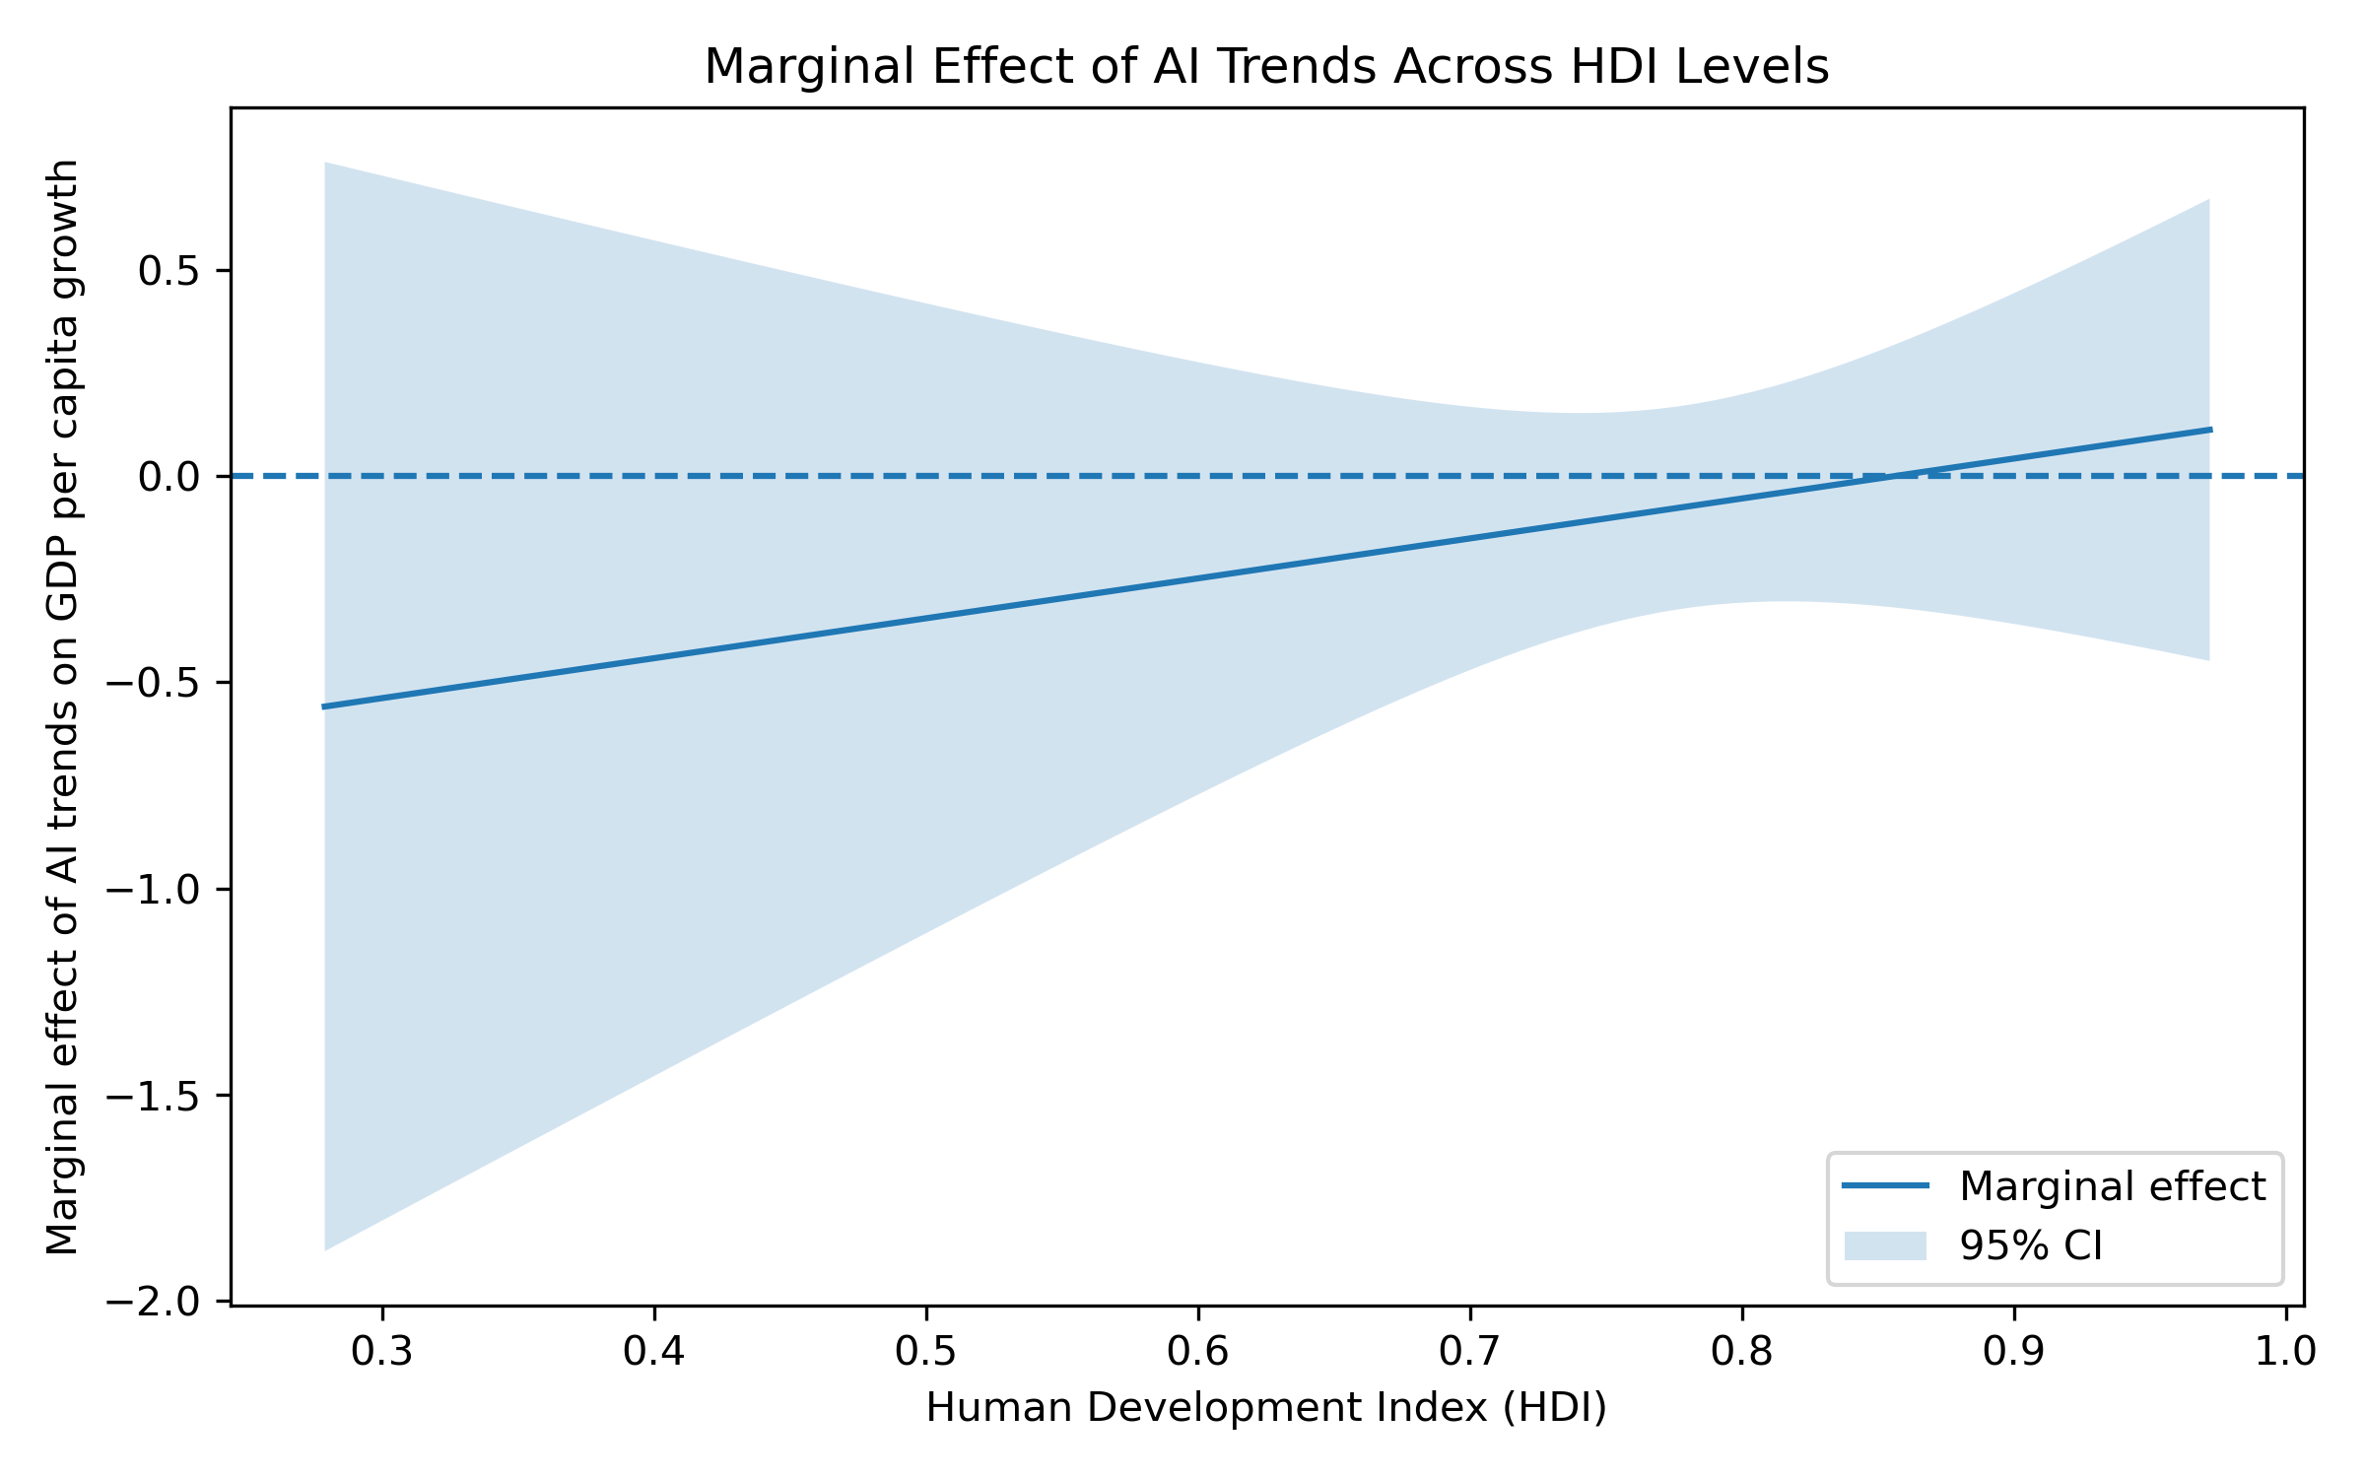
Figure 2. Marginal effects of AI adoption across levels of economic development

It is important to mention here, that while low-HDI countries are generally expected to have higher GDP per capita growth than high-HDI nations due to different macroeconomic factors and convergence effects. AI still seems to have more favourable economic effects in high-HDI countries than in low-HDI ones. This is in line with the hypothesis that AI adoption does not necessarily result in the same levels of economic growth when looking at countries with different developmental levels.

Robustness Checks
Several robustness checks were implemented to see how the main findings change when using alternative regression specifications. Figure 3 illustrates how the coefficient of the interaction term between AI Trends and HDI changed in all additional robustness check specifications. Additional tables that present the findings of each robustness check are located in the appendix section.
The first robustness check was carried out to see what difference it makes, if instead of using clustered standard errors on the country level, the model would use HC1 heteroskedasticity-robust standard errors in its specifications. The results reveal that the interaction term’s coefficient largely remains the same, so the results are not influenced substantially by the choice of what standard errors estimation method the model uses.
The second robustness check excludes data from the year 2025, which was important to check, because some variables still had data for 2025 in the initial model. However, the results remained the same, which was expected since both regression models ended up using only data until 2024, because of data availability issues for some variables.
The third robustness check excluded all the outliers that were present in the data. The descriptive statistics table (Table 2) in the methodology section showed that there were many outliers in the GDP per capita growth variable’s observations. This specification excluded the extreme outliers, which were the top and bottom 1 percent of the observations. The findings suggest that the interaction term’s coefficient becomes negative. This means that extreme growth observations influence the results of the regression. However, the confidence interval stays wide, and it includes zero as well. Therefore, this negative coefficient should not be interpreted as evidence against the main findings of this paper, instead it means that the exact relationship between AI trends and HDI is sensitive to extreme observations.
Lastly, the fourth robustness check used lagged AI Trends values to account for the possibility that the effects of AI adoption occur with some initial delay. The coefficient stayed positive but became smaller. This indicates that the interaction term remains similar when using this delayed specification.
To conclude, the robustness checks included valuable insight for the interpretation of the results. They generally provided supportive findings for the main regression’s results. Nevertheless, the confidence intervals are wide for all specifications in Figure 3, therefore the results should be considered with taking this into account.

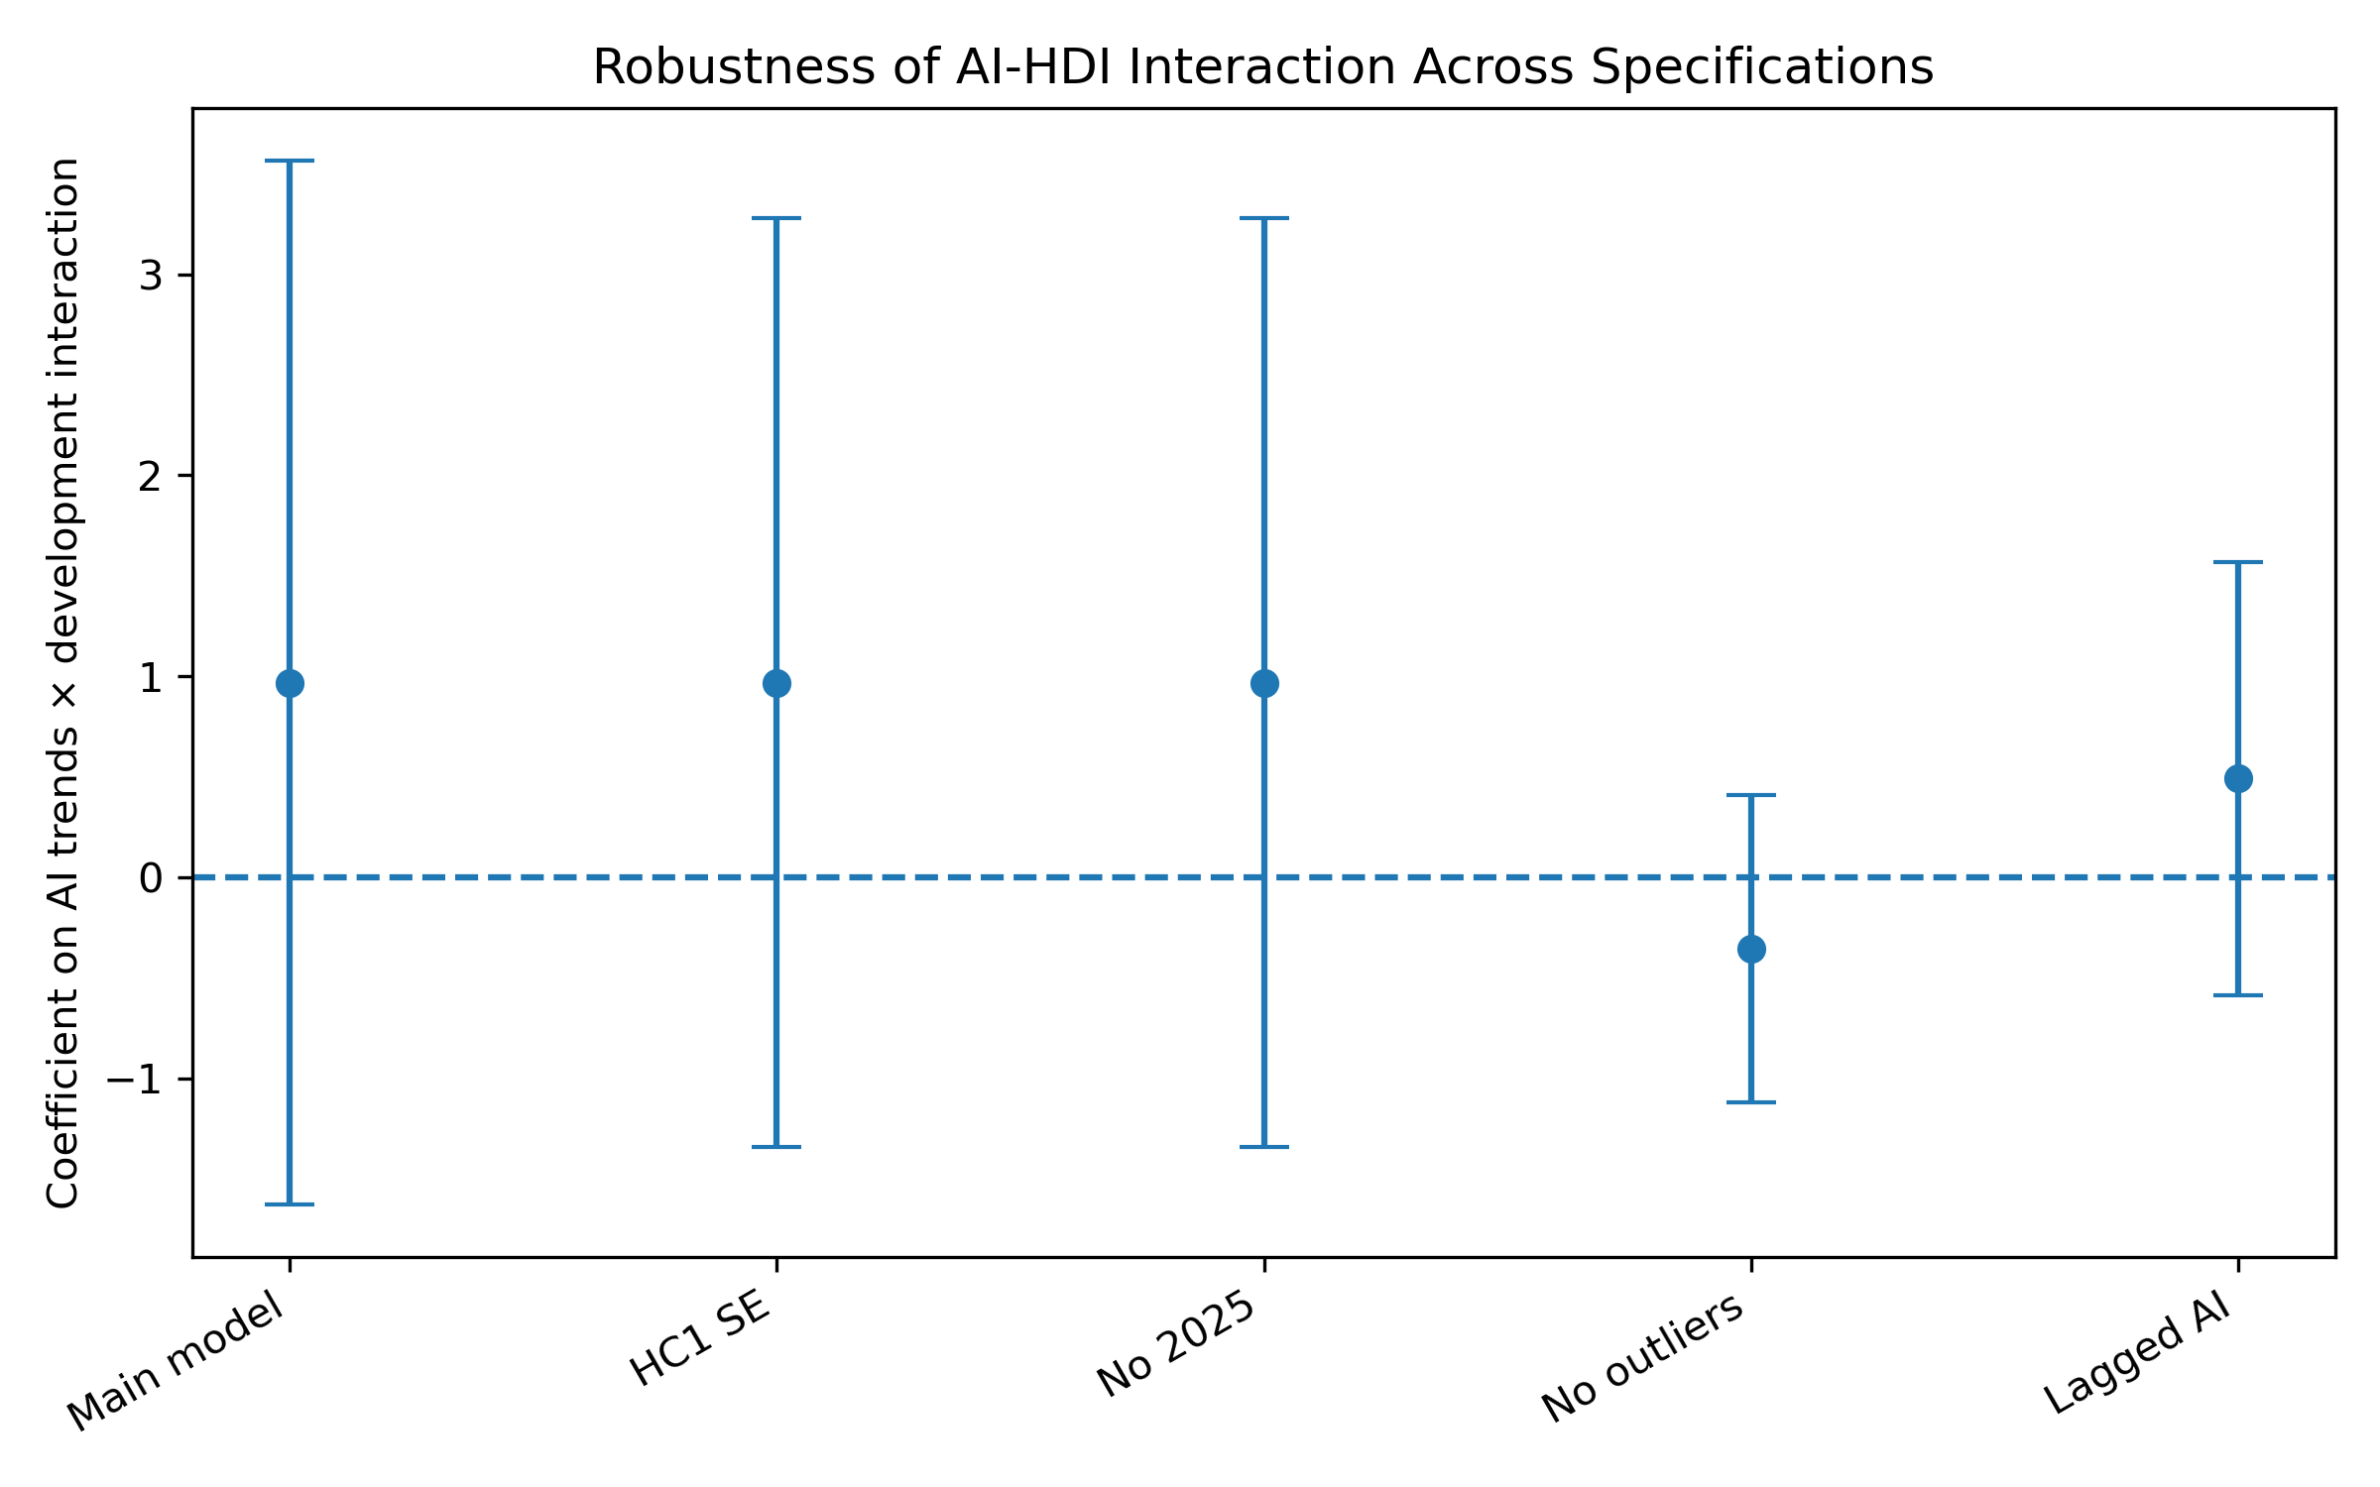
Figure 3. Robustness of AI-HDI Interaction term Across Specifications

Limitations
The results are somewhat consistent with the hypothesis and the theoretical framework, but there are major limitations that must be stated. The most important issue is about the fact that AI adoption is meant to be measured by Google trend data. This variable mostly captures the search interest and general awareness about AI technologies rather than actual statistics about firms or individuals implementing AI tools. Therefore, the results should only be looked at with this distinction in mind, and it must be acknowledged that this result is about AI-related interest and economic growth, which is not a perfect measure of AI adoption, in reality it can only function as an indicator of it.
Secondly, the regression might still suffer from omitted variable bias. There could be various other factors, such as other institutional quality indicators, quality of the education system and research and development spending that could affect AI adoption and economic growth. Adding country and time fixed effects and including several control variables help with this issue, but it cannot fully eliminate it either.
Thirdly, the regression looked at a relatively short time period between 2004 and 2024. This might not be enough time to model the long-term economic effects of AI. This is especially true when we consider that generative technologies only became particularly visible recently. Therefore, this result may capture changes in AI interest and possible adoption within an early-stage transitionary period. This issue is very likely to have an impact on these results, but nevertheless the analysis could only use data from this time period. Considering these limitations, the results should be interpreted with some caution.

Conclusions
The central focus of this paper was on how the relationship between the adoption of artificial intelligence (AI) technologies and economic growth differs across various economic developmental levels. Despite AI’s advantages such as the potential for productivity growth in several sectors of the economy, there is a growing number of papers that research the possible disadvantages that could arise from adopting these technologies. Specifically, the possibility that this technological innovation could further increase global wealth inequality between countries is the primary motivation behind this study.
Initially, the paper explored many different research papers and economic theories to establish its theoretical background. Specific theories such as endogenous growth theory, technological diffusion theory, the idea that AI could be a general-purpose technology and more were used in this process. From this literature review, came the paper’s hypothesis, which states that economic growth that is attributed to adopting AI is conditional on economic development. In other words, as countries become more developed, they should be better positioned to take advantage of the potential economic gains from AI innovations.
The empirical analysis provides partial support for this hypothesis. The baseline regression specification showed that AI-related interest, measured by Google Trends data, does not appear to have a statistically significant relationship with GDP per capita growth, when only looking at it independently. Instead, the baseline model predicts that traditional macroeconomic variables such as investment, trade openness and inflation are the most of important factors for economic growth. Investment and trade openness are positively related to GDP per capita growth and inflation is negatively related. These findings are largely consistent with established economic theory and the theories in the literature review.
In addition, the extended model introduced the interaction term between AI trends and the Human Development Index (HDI), which represents the main variable of interest in this paper. The coefficient for this term was positive, suggesting that AI adoption’s effect on GDP per capita growth increasingly becomes positive as HDI increases. However, the coefficient remained insignificant. As a consequence, these findings cannot be interpreted as conclusive evidence.
The results were illustrated further in the marginal effects analysis by separating the results for low, mean and high HDI countries. While the estimate for low levels of human development and mean levels of development was negative, the estimate for high HDI countries became close to zero. The only countries that had slightly positive effects were for the highest HDI countries in the sample. This pattern is mostly consistent with the theoretical framework that was developed in the literature review section.
There are several theories that could prove explanations for these findings. Countries with high HDI scores usually have better functioning institutions, a more educated workforce and a more efficient digital infrastructure, these conditions create more opportunities for them to take advantage of AI’s productivity enhancing potential. On the other hand, lower HDI levels usually mean that these economies are still developing and that even if they adopt AI technologies, partially because of various macroeconomic factors and the lack of functioning institutions they are still unable to fully gain substantial economic benefits from implementing them, especially in the short term.
Another theory that is consistent with these findings is Romer’s endogenous growth model. This model highlights the importance of structural and institutional factors when modelling economic growth. In this view, AI has to be adopted in the right structural and institutional environment to produce significant economic gains. Furthermore, diffusion of innovation theory states that the adoption of highly advanced technologies occurs unevenly across different developmental levels.
The robustness checks generally support the findings of the paper. When alternative standard errors methods were used and when observations from 2025 were excluded, the coefficients remined largely the same. The robustness check where lagged AI trends variable was used provided similar results and coefficients stayed stable. However, the specification where the outliers from the GDP per capita growth variable were excluded showed that the interaction effect is sensitive to extreme observations. Furthermore, the confidence intervals around the results remained relatively large.
The implication that AI could increase global inequality comes up when analysing these results. The findings suggest that advanced economies may benefit substantially more from adopting these technologies, thereby widening the economic gap between developed and developing nations. The findings contribute further evidence to the growing research around this topic. However, the results do not imply that less developed countries can never take advantage of this technological innovation, rather that they will not be able as long as they do not possess the right kind of institutions and structural frameworks to implement them. This suggests that they might still benefit, but only in the longer term once certain conditions are met.
In addition, this study has some major limitations, which were discussed in the previous section. There are some ways that this research could be improved and expanded in the future. Most importantly, getting data from actual firms and investments or statistics around AI adoption rates could measure the variable of AI adoption in a more precise way than only looking at google trends data. Furthermore, future research could take advantage of more data on AI adoption that could become available overtime.
In conclusion, the key results of this thesis suggest that the effects of AI adoption on economic growth could be conditional on a country’s economic development. With these findings, the paper contributes to the existing literature in many ways. Firstly, the analysis has a cross-country perspective, meaning that it has panel data across many countries in the period between 2004 and 2024. Secondly, its focus is on the interaction between AI adoption and economic development, while most papers still tend to focus on AI adoption alone. Lastly, the regression provides findings about the possible distributional effects of AI-driven economic growth between nations. This topic remains relatively underexplored in the current literature.

Appendix
The appendix presents additional results and figures that were not included at the end in the results section.

Additional Summary of the Results
To further summarize these results, it can be said that these findings broadly support the general hypothesis of the paper. The baseline model and the extended model reveal similar results. Both figure (4) and table 4 are meant to illustrate the key findings. Figure (4) shows the predicted GDP growth effects of AI trends across different HDI levels, the figure differentiates between low, mean and high HDI levels.

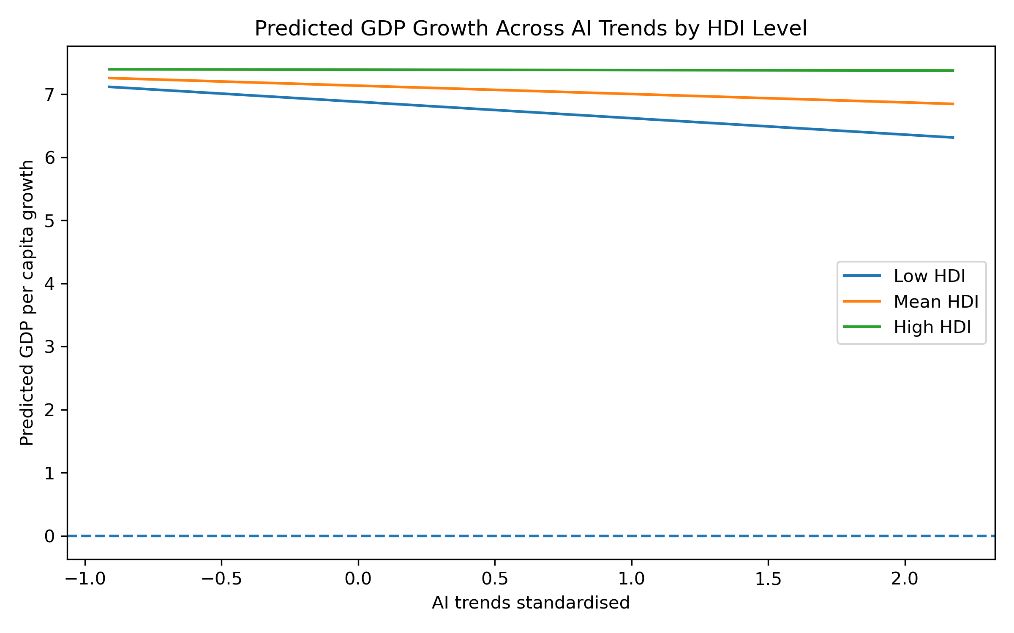
Figure 4. Predicted GDP Growth effect of AI Trends across HDI levels

Table 4. Marginal Effects of AI Trends at different HDI levels
HDI level | HDI value | Marginal effect of AI trends
Low HDI (25th percentile) | 0,588 | -0,26
Mean HDI | 0,72 | -0,133
High HDI (75th percentile) | 0,85 | -0,006

In addition, table 4 shows the same results, but only in a table form with the actual numbers that the model predicts. The low HDI countries have negative (-0,26) marginal effect of AI trends, the mean HDI countries have less negative (-0,133) and high HDI countries have an almost zero (-0,006) marginal effect.

Additional Coefficient Tables for Robustness Checks
The actual tables that contain all the results for the robustness checks include coefficients for all individual countries and years. These can be found in the GitHub repository page, the link for this page is in the references section. The different specifications are presented in tables 5,6,7 and 9.

Table 5. Robustness checks for using HC1 standard errors
 | Coefficient | Std.Error | P-value
Intercept | -1,5449 | 5,2197 | 0,7673
ai_trends_std | -0,8294 | 0,9408 | 0,3780
hdi | 1,9422 | 6,9550 | 0,7800
ai_trends_std_x_hdi | 0,9683 | 1,1790 | 0,4115
investment | 0,1405 | 0,0287 | 0
fdi | 0,0051 | 0,0029 | 0,0850
trade_openness | 0,0464 | 0,0090 | 0
inflation | -0,0172 | 0,0056 | 0,0021

Table 6. Robustness checks for excluding 2025 observations
 | Coefficient | Std.Error | P-value
Intercept | -1,5449 | 5,2197 | 0,7673
ai_trends_std | -0,8294 | 0,9408 | 0,3780
hdi | 1,9422 | 6,9550 | 0,7800
ai_trends_std_x_hdi | 0,9683 | 1,1790 | 0,4115
investment | 0,1405 | 0,0287 | 0
fdi | 0,0051 | 0,0029 | 0,0850
trade_openness | 0,0464 | 0,0090 | 0
inflation | -0,0172 | 0,0056 | 0,0021

Table 7. Robustness checks for no Extreme GDP per Capita Outliers
 | Coefficient | Std.Error | P-value
Intercept | 1,6671 | 3,7324 | 0,6551
ai_trends_std | 0,3118 | 0,2702 | 0,2485
hdi | -1,4625 | 5,0328 | 0,7714
ai_trends_std_x_hdi | -0,3566 | 0,3899 | 0,3604
investment | 0,1306 | 0,0168 | 0
fdi | 0,0038 | 0,0027 | 0,1561
trade_openness | 0,0333 | 0,0051 | 0
Inflation | -0,0167 | 0,0050 | 0,0008

Table 8. Robustness checks for Lagged AI Trends
 | Coefficient | Std.Error | P-value
Intercept | -2,1649 | 5,3602 | 0,6863
ai_trends_lag1 | -0,5344 | 0,3928 | 0,1737
hdi | -0,7906 | 7,0936 | 0,9113
ai_lag1_x_hdi | 0,4904 | 0,5497 | 0,3723
investment | 0,1554 | 0,0297 | 0
fdi | 0,0045 | 0,0029 | 0,1163
trade_openness | 0,0418 | 0,0079 | 0
inflation | -0,0183 | 0,0056 | 0,0011

(Table 9. Robustness checks for Using AI readiness instead of HDI)
 | Coefficient | Std.Error | P-value
Intercept | 1,1713 | 0,6430 | 0,0685
ai_trends_std | -0,4762 | 0,6572 | 0,4687
ai_readiness_2023 | -1,9099 | 0,6968 | 0,0061
ai_x_readiness | 0,6417 | 1,1650 | 0,5818
investment | 0,1308 | 0,0232 | 0
fdi | 0,0050 | 0,0033 | 0,1229
trade_openness | 0,0452 | 0,0088 | 0
Inflation | -0,0214 | 0,0058 | 0,0002

References
Acemoglu, D. (2025). The Simple Macroeconomics of AI. Economic Policy, (121), 13–58. (2154534).
AI Preparedness Index (AIPI)—AI Preparedness Index. (n.d.). Retrieved February 11, 2026, from https://www.imf.org/external/datamapper/AI_PI@AIPI
AI Tools in Society: Impacts on Cognitive Offloading and the Future of Critical Thinking. (n.d.). Retrieved April 16, 2026, from https://www.mdpi.com/2075-4698/15/1/6
Artificial Intelligence and Economic Growth | NBER. (n.d.). Retrieved May 22, 2026, from https://www.nber.org/papers/w23928
Artificial intelligence—Explore—Google Trends. (n.d.). Retrieved February 11, 2026, from https://trends.google.com/trends/explore?date=2004-01-01%202026-01-01&q=Artificial%20intelligence&hl=en-us
Babina, T., Fedyk, A., He, A., & Hodson, J. (2024). Artificial intelligence, firm growth, and product innovation. Journal of Financial Economics, 151, 103745. https://doi.org/10.1016/j.jfineco.2023.103745
Batabyal, A. A., Kourtit, K., & Nijkamp, P. (2025). Artificial intelligence based technologies and economic growth in a creative region. Economics of Innovation and New Technology, 34(5), 782–796. https://doi.org/10.1080/10438599.2024.2374273
Bender, E. M., & Koller, A. (2020). Climbing towards NLU: On Meaning, Form, and Understanding in the Age of Data. In D. Jurafsky, J. Chai, N. Schluter, & J. Tetreault (Eds.), Proceedings of the 58th Annual Meeting of the Association for Computational Linguistics (pp. 5185–5198). Association for Computational Linguistics. https://doi.org/10.18653/v1/2020.acl-main.463
Bjola, C. (2022). AI for Development: Implications for Theory and Practice. Oxford Development Studies, 50(1), 78–90. (1963166). https://doi.org/10.1080/13600818.2021.1960960
Cazzaniga, M., Jaumotte, F., Li, L., Melina, G., Panton, A. J., Pizzinelli, C., Rockall, E. J., & Tavares, M. M. (2024). Gen-AI: Artificial Intelligence and the Future of Work. Staff Discussion Notes, 2024(001). https://doi.org/10.5089/9798400262548.006.A001
Collins, C., Dennehy, D., Conboy, K., & Mikalef, P. (2021). Artificial intelligence in information systems research: A systematic literature review and research agenda. International Journal of Information Management, 60, 102383. https://doi.org/10.1016/j.ijinfomgt.2021.102383
Damioli, G., Van Roy, V., Vertesy, D., & Vivarelli, M. (2025). Is artificial intelligence leading to a new technological paradigm? Structural Change and Economic Dynamics, 72, 347–359. https://doi.org/10.1016/j.strueco.2024.12.006
Documentation and downloads | Human Development Reports. (n.d.). Retrieved February 11, 2026, from https://hdr.undp.org/data-center/documentation-and-downloads
Endogenous Technological Change by Paul M. Romer: SSRN. (n.d.). Retrieved May 14, 2026, from https://papers.ssrn.com/sol3/papers.cfm?abstract_id=226703
Fixed Effects Estimation of Large-TPanel Data Models | Annual Reviews. (n.d.). Retrieved May 15, 2026, from https://www.annualreviews.org/content/journals/10.1146/annurev-economics-080217-053542
Freire, C. (2025). Is this time different? Impact of AI in output, employment and inequality across low, middle and high-income countries. Structural Change and Economic Dynamics, 73, 136–157. https://doi.org/10.1016/j.strueco.2024.12.016
GDP per capita growth (annual %) | Data. (n.d.). Retrieved February 11, 2026, from https://data.worldbank.org/indicator/NY.GDP.PCAP.KD.ZG?end=2024&name_desc=false&start=1961&view=chart
Goel, R. K., & Nelson, M. A. (2025). Awareness of artificial intelligence: Diffusion of AI versus ChatGPT information with implications for entrepreneurship. The Journal of Technology Transfer, 50(1), 96–113. https://doi.org/10.1007/s10961-024-10089-3
Golic, Z. (2019). Finance and Artificial Intelligence: The Fifth Industrial Revolution and Its Impact on the Financial Sector. Proceedings of the Faculty of Economics in East Sarajevo / Zbornik Radova Ekonomskog Fakulteta u Istočnom Sarajevu, 19, 67–81. (2191760).
Gomes, O. (2025). The Human Capital—Artificial Intelligence Symbiosis and Economic Growth. De Economist, 173(2), 331–365. https://doi.org/10.1007/s10645-025-09452-y
Khan, M. S., Umer, H., & Faruqe, F. (2024). Artificial intelligence for low income countries. Humanities and Social Sciences Communications, 11(1), 1422. https://doi.org/10.1057/s41599-024-03947-w
Liu, F., & Liang, C. (2025). Analyzing wealth distribution effects of artificial intelligence: A dynamic stochastic general equilibrium approach. Heliyon, 11(2), e41943. https://doi.org/10.1016/j.heliyon.2025.e41943
MIAH, M. (2025). Ethical AI for Inclusive Economic Growth. Informatica Economica, 29(4), 35–46. (190974277). https://doi.org/10.24818/issn14531305/29.4.2025.04
Minniti, A., Prettner, K., & Venturini, F. (2025). AI innovation and the labor share in European regions. European Economic Review, 177, 105043. https://doi.org/10.1016/j.euroecorev.2025.105043
Rogers, E. M. (1983). Diffusion of innovations (3. ed). Free Press [u.a.].
Singh, S. (2025, November 20). ChatGPT Users Statistics (February 2026) – Growth & Usage Data. DemandSage. https://www.demandsage.com/chatgpt-statistics/
The Impact of Artificial Intelligence on Innovation | NBER. (n.d.). Retrieved May 22, 2026, from https://www.nber.org/papers/w24449
The Productivity J-Curve: How Intangibles Complement General Purpose Technologies—American Economic Association. (n.d.). Retrieved May 22, 2026, from https://www.aeaweb.org/articles?id=10.1257/mac.20180386
TURING, A. M. (1950). I.—COMPUTING MACHINERY AND INTELLIGENCE. Mind, LIX(236), 433–460. https://doi.org/10.1093/mind/LIX.236.433
Who on Earth Is Using Generative AI ? (2024). https://doi.org/10.1596/1813-9450-10870
World Development Indicators | DataBank. (n.d.). Retrieved February 24, 2026, from https://databank.worldbank.org/source/world-development-indicators#
Yang, C.-H. (2022). How Artificial Intelligence Technology Affects Productivity and Employment: Firm-level Evidence from Taiwan. Research Policy, 51(6), 104536. https://doi.org/10.1016/j.respol.2022.104536

For all calculations and coding here is the publicly available GitHub link: https://github.com/MatthiasRcode/Matyas-Thesis.git

Planning
Time Periods | Key goals | Deadlines
Febr 23 - March 4 | Polishing the draft of the proposal according to the comments that I have received and having my first regression results (just to see the possibilities). | March 4 - Research Proposal
March 5 - Apr 17 | Working on the thesis again based on the feedback from the supervisor. Improving the regression model and results. | Apr 17 - First Draft
Apr 18 - May 20 | Revisiting all sections of the paper and changing it according to the preliminary results.
May 21 - 29 | Finishing the draft version of the paper, this week it should only be some minor changes. | May 29 – Thesis Draft
May 30 - Jun 3 | Making the presentation based on the paper. | Jun 3 - Presentation
Jun 4 - 12 | Correcting the paper, if necessary, based on feedback. | Jun 12 - Final Thesis

